**Name:- Amol Sakharam Gaikwad**

**Class:-BECO**

**Roll NO: COBA018**

**Code :-**

**# Recursive Fibonacci**

def fibonacci(n):

if (n<=1):

return n

else:

return(fibonacci(n-1)+(n-2))

n = int(input("Enter numbers of terms :"))

print("Fibonacci sequence:")

for i in range(n):

print(fibonacci(i))

**Output:-**

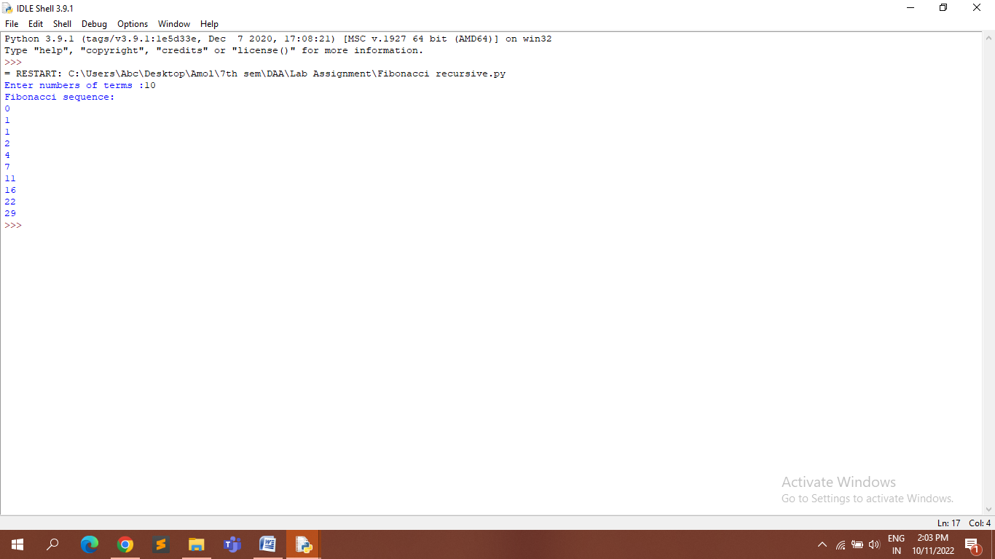

**# Non-Recursive Fibonacci:-**

def fib(n):

if n==1:

return [1]

if n==2:

return [1,1]

fibs = [1,1]

for i in range(2,n):

fibs.append(fibs[-1]+fibs[-2])

return fibs

print(fib(1))

print(fib(2))

print(fib(3))

print(fib(8))

**Output:-**

